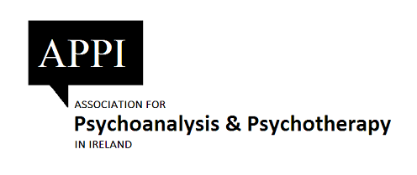

Continuous Professional Development
Log book

Name:
Category of Membership: (Please tick one)
Full Member _____
Conditional Reg. Prac. Member _____
Reg. Prac. Member _____
Student Member ______
Period covered: From __________ To ______________

Email __________________________ Mobile _________________

Name: Printed ________________________ Signature ___________________

Date _____________

Continuous Professional Development

ICP membership means that members are now required to undertake CPD on an on-going basis and to maintain a record of such activities. CORU have indicated that this will be a requirement of Statutory Registration. It is the responsibility of all members to maintain their own CPD record. Appended is a log which you may find useful in keeping track.
The CPD system operates over a five year cycle. For existing members this cycle is backdated to January 2018 and will run to December 2023. For new members, this five-year cycle will run from the date of becoming an accredited member. A requirement has been set of 250 credits over the five-year cycle, averaging 50 Credits per annum.

Not more than 75 can come from one activity, e.g. reading group, attending courses or conferences etc. See below for accreditable activities.

CREDITS

a) ongoing analysis - 20 credits per year
b) ongoing supervision - 15 credits per year
c) attendance at conferences, symposia, workshops - the credits will be specified but are usually 5
d) ongoing participation in relevant committees - 15 credits per year
e) teaching courses or giving workshops - 15 credits per year
e) writing articles or presentation at conferences - 10
e) participation in cartels/reading groups - 10
f) personal study or other relevant personal activity - 1 credit per 5 hours, maximum 20 per year

Please add additional pages as required.
Date/Time  of completion | CPD points | Title of activity:  Event/Course/Workshop/  Lecture/Talk | Awarding Body / Institute / Organisation/ Presenter | Supporting Documentation Available Yes/No  keep records of all events attended e.g., brochure, cert of attendance etc.
15th Sept 2018  9.00 – 1.00 pm | 4 | Clinic of Discreet Madness: Working Psychoanalytically with Couples | APPI | Cert of attendance

I declare that my CPD Portfolio and Log is an accurate record of my activities.

Name: ____________________________ (Print)

Name: ____________________________ (Signature)

Date: _____________________________

